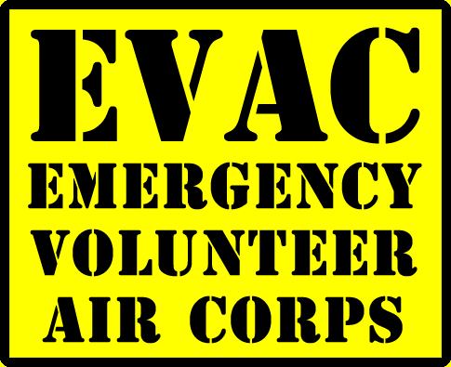
Disaster Airlift Response Plan Exercise Information
Goal; To provide hands on training for multiple county ground support teams and the pilots of the seaplane community on the functional flow, organization, logistics and general layout of the Washington Base and overall seaplane operations. Successfully move supplies from NW Seaplanes at Renton Field to Kenmore Air (using Washington Seaplane Pilots Association planes) and No Town Left Behind then ground transport to Mary’s Place. Said supplies will have been pre-stagged days before after being flown from Walla Walla out of impact area hub by the Washington Pilots Association DART.

Secondary Goal; See if HAM communication can be successfully established between Washington Base location, Clallam, Jefferson, Kitsap and Mason County. OCENS satellite based system demonstration, could this be good additional com’s pathway. If feasible can two way HAM com’s be established between Kenmore Air mobile HAM site and mobile HAM at NW Seaplanes to provide on site updates/plane departure from NW Seaplanes to Kenmore Air operations site.

Involved aspects; Identifying roles, communication flow, aircraft parking in relation to patient movement, patient tracking/aircraft tracking methods, posting planes for unloading of cargo, cargo placement at base for ground transport out and determine effectiveness. Managing No Town Left Behind ground convoy, loading of load out vechiles for Mary’s Place.

Secondary aspects; Can HAM’s successfully transmitted to Washington Base the needed information to appropriately configure and dispatch aircraft out. Information like cloud deck, sea state, wind ..etc. and also patient triage colors/ambulatory or non-ambulatory. OCENS satellite system demonstration, could this prove to be a good additional com’s pathway.

Identified critical roles/forms to be tested; DART forms along with triage aspects and overall management of a base lake location. What forms do HAM’s need to get information transmitted correctly? OCENS satellite based communications system demonstration. Cargo movement/No Town Left Behind logistics/support of Base Lake operations.

Summary; On April 27, 2019 the float pilots from the WSPA will meet at NW Seaplanes at Renton Field to load up the approximate 2,000 lb’s that was previously flown over from Walla Walla by the WPA state level DART pilots. Once loaded they will transport to Washington Base, i.e. Kenmore Air’s main base at the north end of Lake Washington. This is occurring along with other emergency resources from multiple counties coming to Washington Base and the ground convoy from No Town Left Behind that convoyed up days earlier from California, to practice/refine the water born element of the DARP/WCGARP. This will involve multiple aspects of medical, flight and ground support functions. This will also have HAM communication component worked in. Once planes are loaded at Washington Base, injury lists will be sent to the HAM operators within the participating counties. The drill will start once those counties with the list call back to Washington Base over the HAM radios the triage injuries etc. Once Washington Base receives then we’ll unload planes and start on site triage and reload. We will also unload cargo for ground transport to Marry’s Place.

Scenario; We have had a magnitude 8.5 earthquake that lasted for about 5 minutes. All pass highways are down. We have lost major airports. All hospitals west of the Cascades are either damage, collapsed or due to patient volume incapacitated. We have also had a tsunami of 80 feet in height along the coast from upper part of California to lower part of Vancouver Island. Both Base Lakes are up and weather is clear to have over flights direct from Base Lakes and also American Lake and Renton Field Transfer Point are still up. Ft. Lewis/McChord lost McChord field, but the field on Ft. Lewis is still up.

Time Line;

7:30 am No Town Left Behind ground prep start.

9:00 am Ground safety brief for ground support personnel (those arriving
Peninsula)

9:30 am Medical Team sets up triage area/equipment, coms section sets
up communication location, flaggers position at end of docks, dock leads position, ramp manager collocates with HAM location and wheels up spotters.

10:00 am Planes arrive and are parked.

11:45 am 2nd safety brief that includes pilots, go over objectives for exercise

12:15 pm to 1:15 pm Lunch

1:15 pm Load short the Kenmore Air or subsequent WSPA aircraft simulating Kenmore Air craft with patients plus medical attendents and also ambulances if present. Once aircraft loaded assigned injuries to respective counties that have been able to successfully establish a com link.

2:00 pm to 3:00 pm Exercise starts when counties that have successfully established
Com links call in their injury list.

3:00 pm to 5:00 pm Additional hands on loading practice for those desiring and Alan
Barnard will review DART forms for further learning.
Additionally Mark Freeberg the CEO of OCENS will give a live demonstration of the text base satellite communications system.

5:00pm Wrap up, go over what went right and what needs
Improvement. For those that would like further opportunity to discuss further development/upcoming trainings we can also
have this as additional time for that.

Address for training location/Kenmore Air;
Kenmore/Lake Washington (Kenmore Air Harbor)
Seaplanes
6321 NE 175th Street
Kenmore, WA 98028
Map

Attendance Roster

Kenmore Air aircraft/pilots/staffing
Washington Seaplane Pilots Association
City of Kenmore EOC Staff
Northshore Fire Department (possibly)
Mark Freeberg the CEO of OCENS
AMR (?)
Clallam County DART Personal
Jefferson County Emergency Staff and DART teams/ground support teams
Kitsap DART teams
Mason County ground support members
No Town Left Behind members
Quinault Native American Nation
Island County DART ground support team members

